Epithelium (plural epithelia) Dr. Khalid

One of the four basic types of tissue in the organ body:, with connective tissue, muscle tissue and nervous tissue. Its line the cavities and surfaces of blood vessels and organs throughout the body.
A sheet of aggregated cells of similar type tightly adhered to each other and site on the basement membrane. Its covered the external and lining internal surface of the body, and may growth to form glands.
All three embryonic germ layers take part in formation of epithelium:
- Ectoderm-------skin
- Endoderm -------digestive system.
- Mesoderm -------blood and lymphatic vessels, body cavities and part of urogenital.
Epithelium rest on the basal lamina -----thin sheet of extacellular matrix (muocopolysaccharide) believed its produced by epithelial cells.
Reticular lamina ---mashwork of rreticular and fine collagen fibers in mucopolysaccharide matrix.
Both basal lamina and Reticular lamina---called basement membrane (can seen by PAS or Silver stain).
Nutrition of epithelium: no blood vessel in this layer so … by diffusion from underlying layer.
Functions of epithelial cells include secretion, selective absorption, protection, transcellular transport, and sensing.

Classification
Generally, epithelial tissues are classified by the number of their layers and by the shape and function of the cells.
There are three main shapes of epithelial cell: squamous, columnar, and cuboidal.
When these cells arranged in a single layer it's called simple epithelium. as squamous, columnar, cuboidal, pseudo-stratified columnar
or in layers of two or more cells (name depend on the shape of external layer) ------ as stratified (layered), as squamous, columnar or cuboidal.

a-Simple epithelium : a single layer of cells, each cell in direct contact with the basement membrane.
In general, are classified by the shape of their cells into four classes:
- Simple squamous epithelium:
Has cells that are wider than their height (flat and scale-like). Single layer, thin flat, scale like cells, irregular shape, spherical or oval nucleus. Line the internal cavities.
Mesothelium----lining--pleura-pericardium- peritone.
Endothelium----lining ---blood and lymph vessels.
Mesenchymal------lining—certain cavities –subarachnoid—subdural—and chambers of eye.
- Simple cuboidal epithelium:
Cells width and height are equal, its appears squares in cross sections.
Low cuboidal
Tall cuboidal
Lines the ducts and secretory units of glands
- Simple columnar epithelium:
Tall, narrow cells-oval or elongated nucleus
Function---absorption or secretion.
- Pseudostratified columnar epithelium. (ciliated or non-ciliated):
Single layer of cells, but with irregular shape and size, the nucleus is at different levels—so appears as several layers. All the cells rest on the basal lamina but not all reach the surface. Either ciliated, non ciliated or goblet.
Found in –respiratory and reproductive system----ciliated
Intestine-----non ciliated
b- Stratified epithelium: multilayered
- Stratified squamous epithelium.
Several layers only the superficial cells having a squamous shape.
Keratinized -----the cells on the surface lost their nuclei and filled with keratin.
Non keratinized ----- the cells of surface have nuclei.
There are three to five cellular layers present.
- Stratum basale.
- Stratum spinosum.—spiny layer
- Stratum granulosum.—(absent in non keratinized epith.)
- Stratum lucidum. (present only in non hairy skin)
- Stratum corneum.—(dead keratinized cells—no nuclei—not present in non keratinized).

- Stratified cuboidal epithelium:
Tow or more layers—outer layer is cuboidal—lining excretory duct of gland

- Stratified columnar epithelium:
Several layers- outer one is tall cells—distal pert of urethra.
- Transitional epithelium:
Stratified with wide variety appearances. –urinary system—lines hollow organs capable of distention like urinary bladder.
The cells become flattened, few layers –(stretched organ)
Cuboidal, several layers—(non stretched organ)

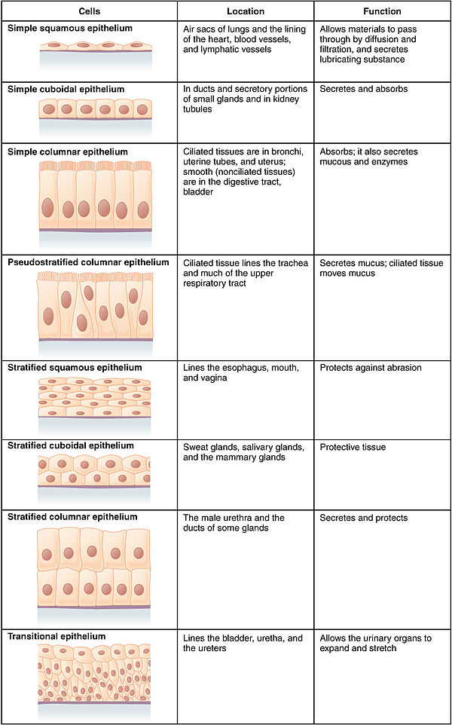
Connective tissue
Connective tissue is one of the four basic types of animal tissue, with epithelial tissue, muscle tissue, and nervous tissue. it's found in between other tissues everywhere in the body, including the nervous system. Mesodermal origin.
All connective tissue consists of three main components:
- Fibers ---differs in quantity and arrangement (elastic and collagenous, reticular fibers).
- Ground substance.
- Cells.
Not all authorities include blood or lymph as connective tissue because they lack the fiber component. All are immersed in the body water.
The cells of connective tissue include: fibroblasts, adipocytes, macrophages, mast cells and leucocytes.
Classification of connective tissue:
- Embryonic C.T
- Mesenchyme.
- Gelatinous C.T
- Adult connective tissue
- Reticular C.T
- Adipose C.T
- Loose C.T
- Dense regular C.T
- Dense irregular C.T-----(collagen C.T—and Elastic C.T)
- Blood

Connective tissue fibers:
The fibers of C.T are differs in quantity and arrangement in various typeS of C.T.
There are three types of fibers:
- Collagen 2- reticular 3- elastic.
- Collagen fibers:
Wavy appearance, pink in color (in H&E stain)
Consist from fiber bundles--- each bundle consist of fibers----each fiber consist of fibrils
The fibril is -----3 coiled polypeptide chains holds by hydrogen bonds.
- Reticular fibers:
Not visible in routine histological stain, but can by silver stain (so its argentaffin fibers) or with PAS stain. Its delicate flexible network around------ capillaries, muscle fibers, adipocytes, hepatocytes and reticular cells in reticular C.T.
- Elastic fibers:
Thick fibers—do not form bundles but occurs as individual branching fibers.
Consists of mucopoly saccharides and elastin. Its resistant to boiling and acid but digest by elastase of pancreas. Found in lung, nuchal ligament and around arteries.
Origin of C.T fibers:
Collagen and reticular fibers -----Fibroblast
Elastic fibers-----Fibroblast and smooth muscle cells.
Ground substance:
The cells and fibers of C.T are embedded in an amorphous ground substance.
Its viscous gel-like. Its muocopolysacchraide –like the hyaluronic acid (larg molecules) stained by (H & E) –clear or slightly blue depend on its sulphated or non sulphated mucopolysccaride
Adult C.T:
- Reticular C.T.
Found in lymph nod, spleen, tonsils, thymus, bone marrow and bold sinus.
Reticular cells—pale staining with many processes, large nucleus strengthen by reticular fibers. Have fibroblastic activity and phagocytic potential.
The R.C.T contains also—histocytes, erythrocytes, leukocytes, macrophage.

- Adipose C.T.:
The cells (adipocyte) have fat deposite (intracytoplasm) with thin layer of cytoplasm and peripheral thin nucleus. There are two types of adipose tissue:
- White adipose tissue
Spherical or polyhedral adipocytes with single droplet lipid (unilocular fat cell), thin peripheral layer cytoplasm containing flattened nucleus. The cells are the main component of the adipose tissue, the cells surrounded by network reticular fibers, the tissue rich with blood vessels.
The fat droplet stained in Sudan III.
- Brown adipose tissue
The adipocytes are smaller than that in white adipose tissue .------its (multiocular) the fat droplets are small (many dropletsin cytoplasm).
The high concentration of cytoplasmic pigment are responsible for the brown color.
Found particularly in rodent—neck- axillary-aorta- mediastinum- and in some locations in domestic animals.
- Loose connective tissue
The most widely distributed C.T in the body. Contain cells and all C.T fibers and amorphous ground substance with many small spaces areolar tissue.
The loose C.T. is found around the blood vessels and nerves, between muscle bundles and layers of smooth muscle of hollow organs, beneath epithelia, make interstitial tissue in most organs…allowing easy movements and shifting of organs, mechanical support and dampening effects on various locations.
Cells of C.T:
- Fibroblast…. Most common –elongated spindle shaped in C.T. but it is spherical or stellate with thin cytoplasmic processes in the large fibrous network.
- Pericytes….around capillary----similar to fibroblast –but have more processes.
- Another free cells found in C.T. like mast, plasma cell.
Fibers of loos C.T.
All three types of fibers.
- Dense connective tissue:
- Dense irregular c.t.
Its specifications are between loose C.T and dense regular C.T.---have the same cells and fibers of loose C.T…but the collagen fibers are more numerous.
Generally, arranged in bundles that cross each other at different angles.
It's found also in thin aponeuroses and muscle fascia. Thus it found in several location in the body. Propria of digestive system, capsule of (lung, spleen, liver, kidney and testis).
- Dense regular C.T.
Lost most of C.T cells---more specialized function than other type of C.T.
It's found as collagen tendon of the muscles, ligament and elastic ligament.
Arranged as parallel collagen fiber bundles which bound together by loose C.T. the fibroblast found between the collagen fibers as flat cells with blunt end in longitudinal section.
Elastic ligament: like the nuchal ligament.-----branching of interconnected parallel elastic fibers surrounded by loose C.T.

